INSTALLATION SERVICE

of the REV. DR. JAMES L. MILLS, SR.

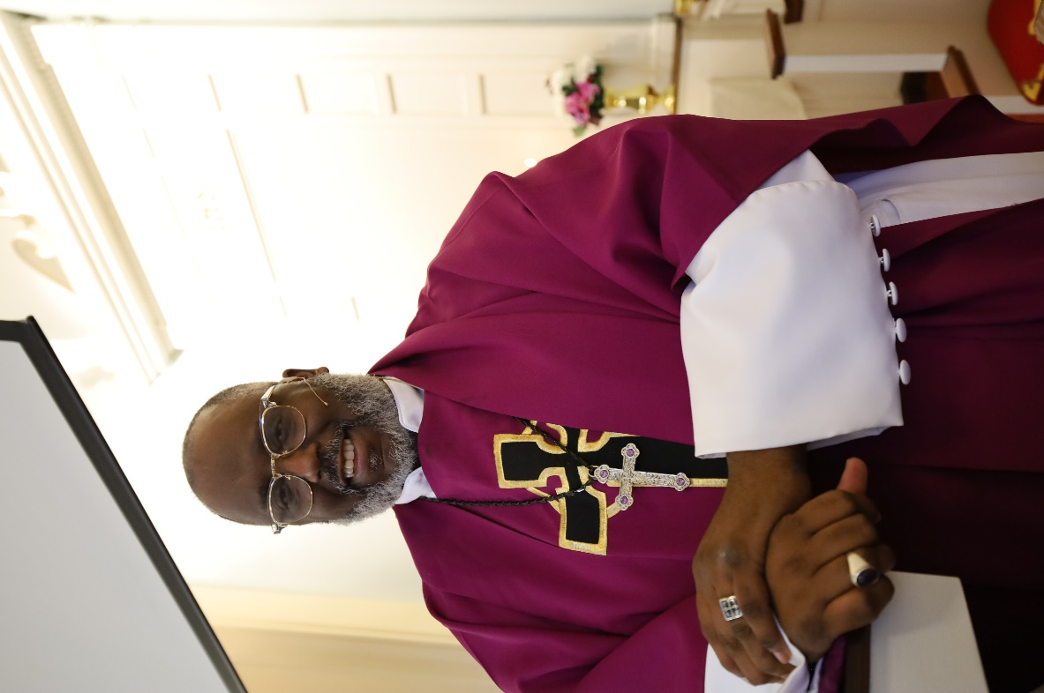

Theme: “My answer is still yes!”

Processional (Red Hymnal-323)

*Holy, holy, holy! Lord God Almighty!  
Early in the morning our song shall rise to Thee;  
merciful and mighty!  
God in three Persons, blessed Trinity!*

*Holy, holy, holy! all the saints adore Thee,  
casting down their golden crowns around the glassy sea;  
cherubim and seraphim, falling down before Thee,  
which wert and art and evermore shalt be.*

*Holy, holy, holy! Lord God Almighty!  
All Thy works shall praise Thy name, in earth and sky and sea;  
Holy, holy, holy! merciful and mighty!  
God in three Persons, blessed Trinity!*

***Welcome and Call to Worship***

Rev. Dr. Richelle Foreman-Gunter (St. Paul’s Baptist Church, West Chester, Pa)

One: Greetings in the name of Jesus Christ,

the head of the church, who is not without witnesses in any age. Hear these words from Timothy:

"As for you, be strong through the grace that is ours

in union with Christ Jesus."

**Many: "Take the teachings you have heard me proclaim**

**in the presence of many witnesses and entrust them to reliable people who will be able to teach and inspire others.”**

One: "Do your best to win full approval in God's sight."

**Many: "Be a worker who is not ashamed of your work**

**and who correctly reflects and lives the message of God's truth.”**

Opening Hymn: Come Thou Fount (Green Hymnal-69)

*Come, thou Fount of every blessing;  
tune my heart to sing thy grace;  
streams of mercy, never ceasing,  
call for songs of loudest praise.  
Teach me some melodious sonnet,  
sung by flaming tongues above;  
praise the mount! I’m fixed upon it,  
mount of God’s unchanging love!*

*Here I raise my Ebenezer;  
hither by thy help I’m come;  
and I hope, by thy good pleasure,  
safely to arrive at home.  
Jesus sought me when a stranger,  
wandering from the fold of God;  
he, to rescue me from danger,  
interposed his precious blood.*

*O to grace how great a debtor  
daily I’m constrained to be!  
Let that grace now, like a fetter,  
bind my wandering heart to thee.  
Prone to wander, Lord, I feel it,  
prone to leave the God I love;  
here’s my heart; O take and seal it;  
seal it for thy courts above.*

SCRIPTURE READINGS:

The Psalter: Psalm 9:1-10

Tiffani Todd (Wentz’s United Church of Christ, Lansdale, PA)

*I will give thanks to the Lord with my whole heart; I will tell of all your wonderful deeds.* ***2****I will be glad and exult in you; I will sing praise to your name, O Most High.* ***3****When my enemies turned back, they stumbled and perished before you.****4****For you have maintained my just cause; you have sat on the throne giving righteous judgment.* ***5****You have rebuked the nations; you have destroyed the wicked; you have blotted out their name forever and ever.*

***6****The enemies have vanished in everlasting ruins; their cities you have rooted out; the very memory of them has perished.* ***7****But the Lord sits enthroned forever; he has established his throne for judgment.* ***8****He judges the world with righteousness; he judges the peoples with equity.* ***9****The Lord is a stronghold for the oppressed, a stronghold in times of trouble.* ***10****And those who know your name put their trust in you, for you, O Lord, have not forsaken those who seek you.*

The Gospel: John 1: 5-12

Rita Cipriano (Wentz’s United Church of Christ, Lansdale, Pa)

***5****The light shines in the darkness, and the darkness did not overtake it.* ***6****There was a man sent from God whose name was John.****7****He came as a witness to testify to the light, so that all might believe through him.****8****He himself was not the light, but he came to testify to the light.****9****The true light, which enlightens everyone, was coming into the world.* ***10****He was in the world, and the world came into being through him, yet the world did not know him.****11****He came to what was his own, and his own people did not accept him.****12****But to all who received him, who believed in his name, he gave power to become children of God,*

The Epistle: 2nd Timothy 4:1-5

Pastor Mike Todd (Wentz’s United Church of Christ, Lansdale, Pa)

*In the presence of God and of Christ Jesus, who is to judge the living and the dead, and in view of his appearing and his kingdom, I solemnly urge you:****2****proclaim the message; be persistent whether the time is favorable or unfavorable; convince, rebuke, and encourage with the utmost patience in teaching.****3****For the time is coming when people will not put up with sound teaching, but, having their ears tickled, they will accumulate for themselves teachers to suit their own desires****4****and will turn away from listening to the truth and wander away to myths.****5****As for you, be sober in everything, endure suffering, do the work of an evangelist, carry out your ministry fully.*

Prayer of Invocation:

Rev. Dr. Wendell Yorkman (Inner Life Ministries, Lancaster, Pa)

Worship & Praise

Worship through Generosity :

“Woke Up Dis Mornin” (Songs of Zion-146)

Woke up dis morn-in wid mah min’ stayed on freedom

Woke up dis morn-in wid mah min’ stayed on freedom

Woke up dis morn-in wid mah min’ stayed on freedom

Hal-le-lu Hal-le-lu Hal-le-lu jah

Hal-le lu Hal-le-lu, Hal-le-lu. jah

Episcopal Greetings:

Bishop Mary Ann Hubert (Restoration Temple, Philadelphia, Pa)

Special Music:

Rev. Dr. Linwood Smith (Bethel AME, York, Pa)

Community Greetings:

Mayor Garry Herbert of Lansdale;

Presentation from PA House Majority Leader Matt Bradford

(Mike Todd)

Introduction of Installation Speaker:

Rev. Dr. Richelle Foreman-Gunter (St. Paul’s Baptist Church, West Chester, Pa)

Sermonic Song “Goodness of God”

The Word Proclaimed: Bishop Dwayne Royster (POWER Interfaith, Philadelphia, PA)

Hymn of Consecration- The Church’s One Foundation (Green Hymnal-544)

*The church's one foundation  
is Jesus Christ, her Lord;  
she is His new creation,  
by water and the word.  
From heav'n He came and sought her  
to be His holy bride;  
with His own blood He bought her,  
and for her life He died.*

*Elect from every nation,  
yet one o'er all the earth,  
her charter of salvation:  
one Lord, one faith, one birth.  
One holy name she blesses,  
partakes one holy food,  
and to one hope she presses,  
with every grace endued.*

*'Mid toil and tribulation,  
and tumult of her war,  
she waits the consummation  
of peace forevermore;  
till with the vision glorious  
her longing eyes are blest,  
and the great church victorious  
shall be the church at rest.*

**SERVICE OF INSTALLATION:**

***Moderator or other official of the Association:***

The Ursinus Association of the Pennsylvania Southeast Conference of the United Church of Christ greets you in the name Jesus Christ our Risen Lord, whose body we are and whose spirit is alive in us.

As we begin this service of installation, it is good we realize that, in our denomination, The United Church of Christ, installation is always the action of an association, but done in cooperation with the local church. Installation confirms and celebrates the covenantal relationship among the local church, it's pastor and teacher, and the United Church of Christ and the wider church.

***Charge to the Congregation: Rev. Antonio L. Villareal***

The sacred relationship between a congregation and pastor is not happenstance but rather a holy arrangement orchestrated by an omniscient God. Today, I invite you, Wentz’s, in front of these assembled witnesses to lovingly enter into this covenant with your new pastor, realizing that this moment in time was actually predestined in eternity, even before the foundations of the world were established. I, as your former Senior Pastor, offer the following charge to you:

I charge you to continue to be a spiritual community of love. The ministry of care and compassion is not simply the role of the pastor. It is the task of this entire church. In addition to caring for and showing compassion to one another, never become so insular that you fail to impact the lives of those outside the church who have no advocate, are mired in hopelessness and ravaged by injustice.

**If you concur, please say, “We accept with the help of God.”**

I charge you to eagerly accept the leadership of Dr. Mills. Great leadership is dependent upon willing and consistent “fellowship.” Trust that he is a person of prayer who desires to lead Wentz’s according to the perfect will of God. Grant Dr. Mills room to make mistakes. A “mistake-free” ministry would simply be evidence of a lack of courage and vision. Sometimes we only know God’s perfect will through trial and error.

**If you concur, please say, “We accept with the help of God.”**

I charge you to foster the creativity and imagination of your pastor. Encourage him to meditate and pray regularly; to appreciate great literature, culture and the arts; and to attend conferences and professional gatherings where his gifts for ministry can be enhanced. Then, invite your pastor to unleash his imagination upon this congregation through profound preaching and teaching that illumines the mind, warms the heart, and persuades people to serve the Lord and humanity with all of their heart, soul and mind.

**If so, please say, “We will, God being our help.”**

I charge you to regularly demonstrate love, care, and compassion for the *total* well-being of your pastor by having fun, laughing and recreating.

**If you will, please say, “We do so willingly.”**

I charge you to strive diligently for unity and peace

**If you will, please say, “We do so willingly.”**

Finally, I charge you to joyously embrace change. God has united you with Dr. Mills for the purposes of transforming Wentz’s, the surrounding community, and even the world. Worry less about the church By-Laws and focus more on God’s call. Worry less about a renovation project and focus more on building up torn-down lives. Worry less about the budget and focus more on God who can supply all your needs. Dream big dreams and wait expectantly as God transforms dreams into reality.

**If you will, please say, “We will with open hearts.”**

***Moderator or other official of the Association:***

Hear these words from The Book of Hebrews

"Therefore, since we are surrounded by so great a cloud of witnesses, Let us lay aside every weight and sin which clings so closely, and let us run with perseverance the race that is set before us."

**All: "Let us look to Jesus, the pioneer and perfecter of our faith,**

**who for the joy that was waiting endured the cross, despising shame, and is seated at the right hand of the throne of God."**

***Moderator or other official of the Local Church***

Wentz’s United Church of Christ, under the guidance of the Holy Spirit, has called Rev. Dr. James L. Mills, Sr. as its pastor and teacher, and respectfully requests that the Ursinus Association install him in this ministry among us, according to the faith and order of the United Church of Christ.

***Representative of The Ursinus Association Committee on Church & Ministry***

The Ursinus Association has reviewed the request of Wentz’s United Church of Christ. We have prayerfully examined James. We confirm that he has been called by God for ministry in this place and declare that he has met all the necessary conditions for installation in this office. We are pleased to install him as your pastor and teacher.

***Moderator or other official of the Ursinus Association***

Rev. Dr. James Mills, please rise and come forward.

Are you willing to heed your call to ministry and enter into covenant with Wentz’s United Church of Christ as their pastor and

teacher, as well as into covenant with us who are The Ursinus Association of the Pennsylvania Southeast Conference of the United Church of Christ?

**Dr. Mills: I am willing, and I promise to serve this church faithfully,**

**preaching and teaching the word of God, administrating the**

**sacraments and fulfilling the office of pastor according to the United Church of Christ.**

All members of Wentz’s who are able, please stand and affirm your covenant with Rev. Dr. James Mills.

We, the members of Wentz’s United Church of Christ,

receive Rev. Dr. James Mills as our pastor and teacher, promising to labor with him in the ministry of the gospel and give to him due honor and support.

We gather with him and the Ursinus Association as a sign

of our mutual ministry in Christ.

All clergy, delegates and other members of the Ursinus Association who are able, please stand and affirm our covenant with Rev. Dr. James Mills.

We, the members of the Ursinus Association of the United Church of Christ, clergy colleagues and fellow laborers gather with you the people and pastor of Wentz’s United Church of Christ as a sign of our covenant and in celebration of our mutual ministry in Christ's name.

*\*Moderator or other designated person of The Ursinus Association and participating clergy come forward for the laying on of hands.*

Prayer of Consecration (Bishop Dwayne Royster with clergy and Association designee)

Benediction: Rev. Dr. James L. Mills, Sr.

Recessional

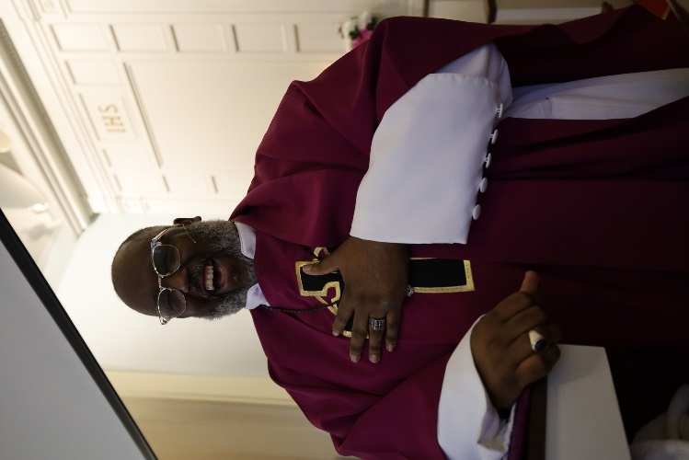

We welcome our new pastor, the Reverend Dr. James L. Mills, to the Wentz’s UCC family. “Rev” — as he likes to be called — brings energy, passion, joy, and the love of God and all of God’s people to share with the community of Lansdale and beyond.

A little bit about Rev: The job might be new, but Mills and his two teenage sons are no strangers to the area. A native of Southeastern Pennsylvania, he brings more than 20 years of experience as a minister and administrator. Ministry is in his blood. Rev’s grandmother served as a pastor in the African-Methodist Episcopal Church for 20 years. Mills shares that family members recall him delivering his first sermon at the age of 8 in his bedroom, standing on a Snoopy trashcan. Rev is self-described as a community focused person: “service in the community, especially around issues of social justice and inclusion, is dear to me.”

Prior to accepting the pastorship at Wentz’s, Rev served as senior pastor with the First Congregational Church of Fair Haven in Vermont. He also serves on the Board of Senior Bishops at the Fellowship of Affirming Ministries, a multidenominational, multinational, primarily African-American group of Christian leaders and laity who practice a theology of radical inclusivity, which engages and ministers to individuals on the margins of society. Rev says his goal is to make the church a place of refuge where people living in those margins can know they are loved and needed. “Even just sitting with them and building trust is a great first step. What I hope to bring the community is a sense that everyone is welcome in the house of the Lord. We are not looking for perfection. We’re all far from perfect – we are trying to make progress.” Rev acknowledges the powerful dynamic of his being an African-American man leading a predominantly white congregation. “I think it speaks volumes that, at this moment, they would pick an African-American man to lead them.” Looking ahead, Mills is eager to make the congregation more active and visible in the greater Lansdale community.

Rev’s post graduate work includes a Masters of Divinity from Boston University and a Doctor of Ministry from Lancaster Theological Seminary.

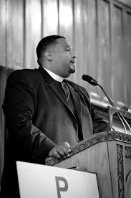

**BISHOP DWAYNE ROYSTER | EXECUTIVE DIRECTOR**

[**DRoyster@powerinterfaith.org**](mailto:droyster@powerinterfaith.org)

Bishop Dwayne D. Royster, a leading voice in modern faith-based activism, wants to change the world. Whether he is serving as a pastor, challenging the status quo as a political activist, educating and empowering communities as a radio show host, or encouraging and inspiring audiences around the country as a writer and public speaker, Bishop Royster’s work is fueled by deep faith and passionate commitment to bringing about social justice.

Bishop Royster has served in pastoral ministry for the past over 26 years in a variety of positions and denominations. Driven by his deep commitment to the four biblical principles of redemption, restoration, renewal and refreshment, Bishop Royster works diligently to meet people where they are and instill in the congregation a need to be like Christ: slow to judge always ready to offer grace and mercy.

Bishop Royster is concluding his tenure as Senior Pastor of Faith United Church of Christ in the North Michigan Park Section of Washington, DC. At the end of September. Bishop Royster is an advocate for preparing congregations for the ministry of availability. Prior to his current role as Senior Pastor, Bishop Royster has had the honor of presiding over the Living Water United Church of Christ (Founder and Senior Pastor); Mid-Town Parish UMC (Pastor); Way of Life Ministries Mennonite Church (Church Planter and Pastor); Harold O. Davis Memorial Baptist Church (Staff Minister) and Camphor Memorial UMC (Associate Pastor). Bishop Royster has also served the United Church of Christ in the following capacities: United Church of Christ Board of Directors (2013-2017); UCC Executive Committee (2016-2017); Penn Southeast Conference Consistory (2008-2012); Philadelphia Association Executive Committee (2008-2012); Philadelphia Association Committee on Ministry (2010-2014) and Ministers for Racial, Social and Economic Justice Board (2010-2014).

Bishop is a graduate of Geneva College’s Center for Urban Theological Studies (BS in Urban Ministry Management), a graduate of the Lutheran Theological Seminary in Philadelphia (M.A. in Religion Degree- African American Church specialization), and has studied at Eastern Baptist Theological Seminary. In addition to his pastoral responsibilities, Bishop Royster is the General Secretary of Higher Ground Christian Fellowship International and serves on the College of Bishops.

Bishop Royster has extensive organizing, advocacy, political and faith leadership experience. He believes that it is imperative that a prophetic faith voice is heard in the halls of power calling for equity and respect for the moral value of every human life. He currently serves as the National Political Director of Faith in Action (formerly the PICO National Network), the nation’s largest faith-based organizing movement committed to racial and economic justice with 40+ federations in 26 States and 4 countries.

Bishop Royster serves as the Founder of the Society for Faith and Justice, an ecumenical religious order committed to a charism of social justice as a spiritual discipline and spiritual practice. Bishop is the Executive Director of the POWER (Pennsylvanians Organized to Witness, Empower and Rebuild) and a former councilman-at-large for the Municipality of Norristown. And when he’s not blogging at “Change The Damn World,” Bishop Royster can be found co-hosting a radio show, “Solutions”, on Philadelphia’s WURD.

Bishop Royster’s work and ministry have been featured in the Philadelphia Tribune, Philadelphia Inquirer, Time Magazine, Philadelphia Daily News, Philadelphia Magazine, New York Times, RT Today, Fox News, Religion and Ethics Weekly (PBS), ThinkProgress, Huffington Post, Fresh Air (PBS), Voice of America, Washington Post, The Washington Informer and many other outlets.

Bishop Dwayne D. Royster is married to the lovely Suzette Royster and together they are the parents of two beautiful daughters.

***Wentz’s United Church of Christ a Brief History***

The beginning of the church dates back to the time of the French and Indian War, and more than a decade before the Revolutionary War. The cornerstone of the first three church buildings erected on the site where the present church now stands, was laid fourteen years before the adoption of the Declaration of Independence and twenty-five years before the signing of the Constitution of the United States. When George Washington became the first President of the United States, Wentz’s Church was already twenty-seven years old.

*The Pre-Wentz’s Era (Skippack Church)*

The founders of Wentz’s Church were a stalwart group of pioneers from the Palatinate (a section of Germany, generally west of the Rhine River was called the Palatinate) who were seeking religious freedom. In 1710 when these German Reformed families came to the Perkiomen Valley. Many of the German Reformed people brought with them German hymn books which included the Heidelberg Catechism (a theological statement) and all or parts of the Palatinate Liturgy.

In 1710 there was no minister in this area, so these Reformed families traveled to Whitemarsh to receive religious instruction from Mr. Paulus Vlecq, who was later ordained a Presbyterian minister. During this period the Reformed families communed with Presbyterians in Germantown. Fourteen Reformed families from Skippack and Whitemarsh are recorded as having attended services conducted by Mr. Vlecq.

In 1748 it was reported the Skippack Church had been scattered resulting from old divisions. Some members in the upper valley began worshipping at Old Goshenhoppen or Indian Creek. Although members were scattered the Skippack Church continued in some fashion until 1755.

In 1760 a few concerned members of the old Skippack Church held a meeting to discuss plans to build a church in Worcester. Worshippers at the time at to travel six miles to attend Sunday services. Two members of this committee each offered an acre of ground for the purpose of building a new church, on which they stipulated either a German Reformed or Presbyterian church should be erected. According to the records, the donating members were John and Christina LeFevre, Jacob and Elizabeth Wentz. The original deeds were dated January, 2 1762 and were later conveyed to Philip Wentz, Peter Wentz, Jacob Weber, Philip Spare, Henry Conrad, and Jacob Reiff, in trust for their decedents and those who may connect themselves to Wentz’s Reformed Church. The erection of the church began in 1762 and was finally completed in 1711.

*The Pastors of Wentz’s when known as the Skippack Church (1725- 1760)*

John Philip Boehm 1725- 1727

The Rev. George Michael Weiss 1727- 1730

The Rev. John Peter Miller 1730- 1731

The Rev. John Bartholomew Rieger 1731- 1734

The Rev. John Henry Goetchy 1735- 1739

John William Straub 1739- 1741

No regular pastor 1741- 1760

The Rev. John George Alsentz 1760- 1762

*Pastors of Wentz’s United Church of Christ after locating to present location in Worcester Township in 1762.*

The Rev. John George Alsentz 1762- 1767

The Rev. John Christopher Faber 1768- 1768

The Rev. Christian Frederick Foering 1769- 1772

The Rev. John Gabriel Gebhard 1772- 1774

The Rev. John William Ingold 1774- 1775

The Rev. John H. Weikel 1775- 1779

No regular pastor 1779- 1784

The Rev. John Herman Winkhaus 1784- 1789

The Rev. Philip Reinhold Pauli 1789- 1793

The Rev. Nicholas Pomp 1793- 1795

The Rev. Samuel Helffenstein 1795- 1799

The Rev. Frederick Herman 1799- 1800 (Supply Pastor)

The Rev. Thomas Pomp 1800- 1801 (Supply Pastor)

The Rev. George Wack 1802- 1844

The Rev. Abraham Bergey 1845- 1845

The Rev. John Naille 1846- 1857

The Rev. Wm. G. Hackman 1858- 1866

The Rev. S.M.K. Huber 1867- 1903

The Rev. D. K. Laundenslager 1903- 1910

The Rev. D. D. Brendle 1910- 1927

The Rev. G. H. Hartman 1927- 1948

The Rev. Ralph L. Folk 1948- 1958

The Rev. C.T. Glessner 1958- 1958 (Supply Pastor)

The Rev. D. Wilson Jaycox 1958-1968

The Rev. Jack Rothenberger 1968- 1968

The Rev. Jesse W. Deardorff 1968- 1991

The Rev. Barbara Lucia 1991- 1992 (Supply Pastor)

The Rev. Dr. William J. Ziegenfus 1993- 1997

The Rev. Jack Rothenberger 1997- 1999

The Rev. Antonio L. Villareal 1999- 2018

The Rev. Scott Lovaas 2018-2019 (Interim)

The Rev. Dale Davis 2019-2022 (Designated Interim)

The Rev. Dr. James L. Mills, Sr. 2022- Present

Acknowledgements

|  |
| --- |
| Rev. Mills would like to extend his personal thanks to the following people for their love, guidance, and support throughout the call process which led him, through God’s spirit, to find a home with Wentz’s United Church of Christ and the surrounding community:  The Congregation of Wentz’s United Church of Christ  *The Members of the Wentz’s United Church of Christ Search Committee:*  Denise Leach, Tom Broderick, Donna Mower, Sarah Schempp, Barbara Taragna, and Tiffani Todd.  *The Members of the Ursinus Association:*  Rev. Suzanne M. Spaulding, Alec Hoffman, Ms. JoAnne Cooper, Rev. Nicholas L. Pence Jr., Rev. Amelie Marie Sell Castillo, Rev. Douglas Hanson, Rev. Ronald Hughes, Peg Schwarz-Green, Laura Walters, Donna Fried, Rev. Suzanne E. Schwarz-Green, Rev. JoEllen Mauger, Rev. Dwayne A. Mosier, and Ned Schillow.  Rev. Kevin McLemore, PSEC Associate Conference Minister for Search and Call |

Wentz’s UCC

Open & Affirming Statement:

We are Wentz’s United Church of Christ, an open and affirming congregation, where your identity and being are cherished. We respectfully welcome all without exception, including those of all races, ethnicities, ages, sexual orientations, gender identities, and family structures. Together we create an open and active community. Everyone is invited to walk with us in our journey. You are welcome here. Whomever, wherever, at all times.

You. Are. Simply. Welcomed.





Wentz’s United Church of Christ

3246 Skippack Pike Lansdale, Pa 19446

www.wentzsucc.org - [office@wentzsucc.org](mailto:office@wentzsucc.org)

610-584-4855

Rev. Dr. James L. Mills, Sr. – Senior Pastor

rev@wentzsucc.org

Ruth Geisel – Consistory President/Elder

Mike Todd- Deacon/Pastoral Assistant

Corey Taragna- Lead Trustee

Donna Mower – Guild President

June Wright- Organist

Laura McLennan and Jim O’Donnell- Music Dept

Matt MacDonald- Technology