**We are an Inclusive Faith Community. All Are Welcomed and All Really Means ALL!**

Sunday, November 26th, 2023, 10am

Twenty-Sixth Sunday After Pentecost

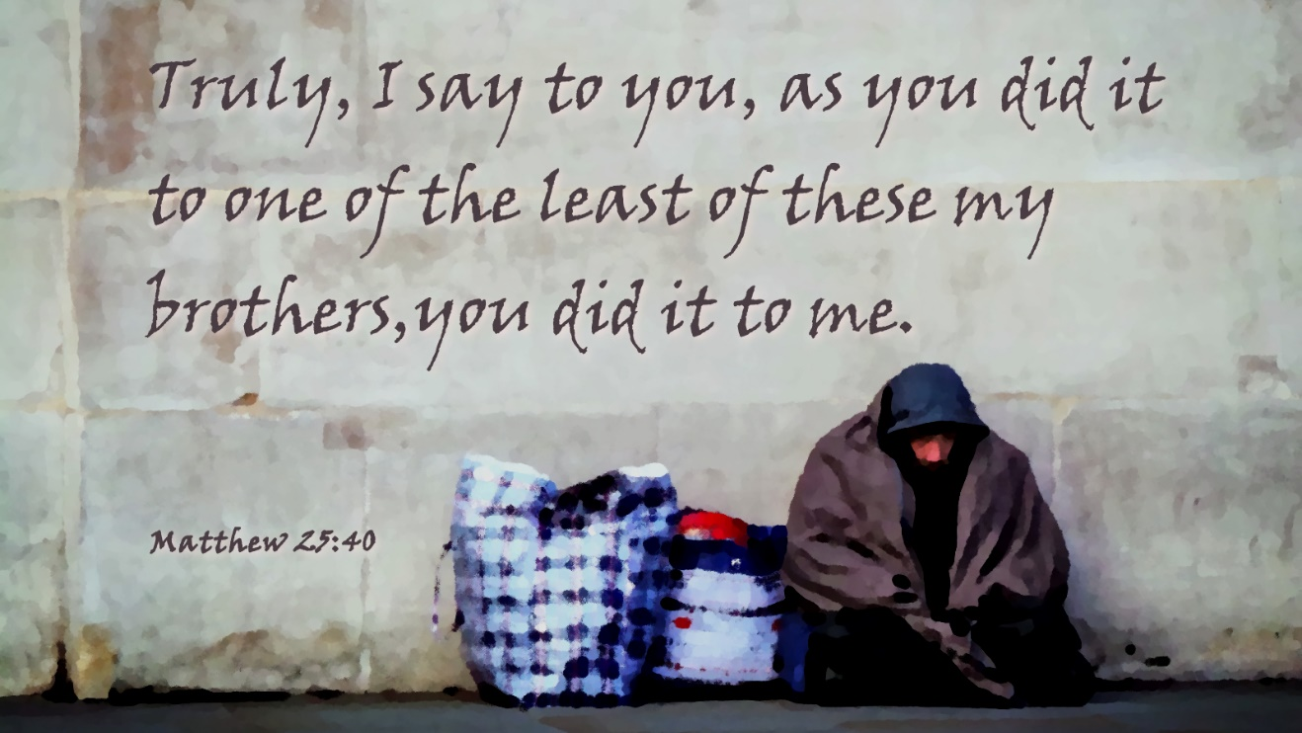

“Put light against light - you have nothing. Put dark against dark - you have nothing. It's the contrast of light and dark that each give the other one meaning.”--[Bob Ross](https://www.azquotes.com/author/12647-Bob_Ross)



Worship Notes:

**PRELUDE**

Greeting and Reply (Mike)

Opening Hymn: **Come, Ye Thankful People, Come (AAHH- 194)**

Come, ye thankful people, come, raise the song of harvest-home:  
all be safely gathered in, ere the winter storms begin;  
God, our Maker, doth provide for our wants to be supplied;  
come to God's own temple, come; raise the song of harvest-home!

All the world is God's own field, fruit unto his praise to yield;  
wheat and tares together sown, unto joy or sorrow grown;  
first the blade and then the ear, then the full corn shall appear:  
grant, O harvest Lord, that we wholesome grain and pure may be.

For the Lord our God shall come, and shall take his harvest home;  
from his field shall purge away all that doth offend, that day;  
give his angels charge at last in the fire the tares to cast,  
but the fruitful ears to store in his garner evermore.

Even so, Lord, quickly come, to they final harvest home;  
Gather thou thy people in, free from sorrow, free from sin,  
there forever purified in thy presence to abide:  
Come, with all thine angels, come, raise the glorious harvest-home!

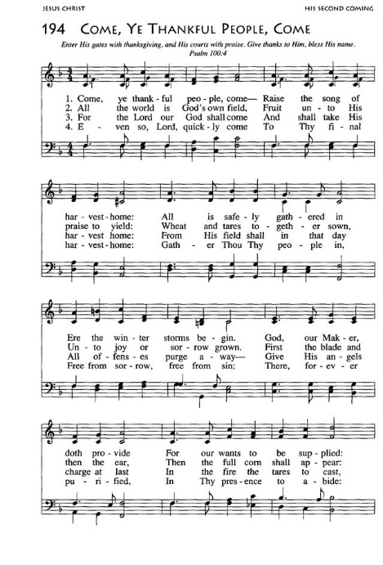

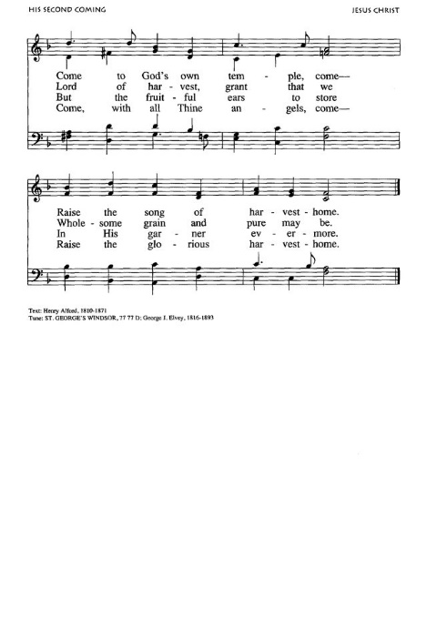

**Our Church’s Mission:**

Welcome all into a loving, inclusive faith community,

Seeking to live out the teachings of Jesus,

Building on our own rich history, actively exploring beliefs and assumptions, and Promoting justice, peace and spiritual growth.

CALL TO WORSHIP (Psalm 100): (Dawn)

ONE: Make a joyful noise to the Lord, all you lands!  
**MANY: Serve the Lord with gladness; come into God’s presence with a song.**

ONE: Know that the Lord is God, our maker to whom we belong;  
**MANY: We are God’s people and the sheep of God’s pasture.**

ONE: Enter the gates of the Lord with thanksgiving and the courts with praise;  
   give thanks and bless God’s holy name.  
**MANY: Good indeed is the Lord, whose steadfast love is everlasting,  
   whose faithfulness endures from age to age.**

### Hebrew Reading: Psalm 95:1-7a (Donna B.)

*1Come, let us sing to the Lord;  
  let us shout for joy to the rock of our salvation.  
 2****Let us come before God’s presence with thanksgiving******and raise a loud shout to the Lord with psalms.*** *3For you, Lord, are a great God,  
  and a great ruler above all gods.  
 4****In your hand are the caverns of the earth;******the heights of the hills are also yours.****5The sea is yours, for you made it,  
  and your hands have molded the dry land.  
 6****Come, let us worship | and bow down,******let us kneel before the Lord our maker.*** *7aFor the Lord is our God,  
  and we are the people of God’s pasture and the sheep of God’s hand.*

### Gospel Reading: Matthew 25:31-46 (Tom B.)

*[Jesus said to the disciples:] 31“When the Son of Man comes in his glory, and all the angels with him, then he will sit on the throne of his glory. 32All the nations will be gathered before him, and he will separate people one from another as a shepherd separates the sheep from the goats, 33and he will put the sheep at his right hand and the goats at the left. 34Then the king will say to those at his right hand, ‘Come, you that are blessed by my Father, inherit the kingdom prepared for you from the foundation of the world; 35for I was hungry and you gave me food, I was thirsty and you gave me something to drink, I was a stranger and you welcomed me, 36I was naked and you gave me clothing, I was sick and you took care of me, I was in prison and you visited me.’ 37Then the righteous will answer him, ‘Lord, when was it that we saw you hungry and gave you food, or thirsty and gave you something to drink? 38And when was it that we saw you a stranger and welcomed you, or naked and gave you clothing? 39And when was it that we saw you sick or in prison and visited you?’ 40And the king will answer them, ‘Truly I tell you, just as you did it to one of the least of these who are members of my family you did it to me.’ 41Then he will say to those at his left hand, ‘You that are accursed, depart from me into the eternal fire prepared for the devil and his angels; 42for I was hungry and you gave me no food, I was thirsty and you gave me nothing to drink, 43I was a stranger and you did not welcome me, naked and you did not give me clothing, sick and in prison and you did not visit me.’ 44Then they also will answer, ‘Lord, when was it that we saw you hungry or thirsty or a stranger or naked or sick or in prison, and did not take care of you?’ 45Then he will answer them, ‘Truly I tell you, just as you did not do it to one of the least of these, you did not do it to me.’ 46And these will go away into eternal punishment, but the righteous into eternal life.”*

READER: This is the word of God, to the people of God

**ALL: Thanks be to God!**

INVOCATION (Mike)

Worship & Praise through Music (Journey )

Passing the Peace of Christ (With Music)

THE LORD'S PRAYER: (Singing) **(Green Hymnal-740)**

Our Father, who art in heaven, hallowed be thy name. Thy kingdom come, thy will be done, on earth as it is in heaven. Give us this day our daily bread, and forgive us our trespasses **(Debts),** as we forgive those who trespass against us **(Debtors).** And lead us not into temptation, but deliver us from evil, for thine is the kingdom and the power and the glory forever. Amen

Announcements

Offering

Doxology (Praise God from whom all blessings flow)

**Praise God from whom all blessings flow; praise him all creatures here below; praise him above the heavenly host: Praise Father, Son, and Holy Ghost. Amen!** *(Creator, Christ, and Holy Ghost)*

Sermonic Hymn: **The Gift of Love (AAHH- 522)**

Though I may speak with bravest fire,  
And have the gift to all inspire,  
And have not love, my words are vain;  
As sounding brass, and hopeless gain.

Though I may give all I possess,  
And striving so my love profess,  
But not be giv'n by love within,  
The profit soon turns strangely thin.

Come Spirit, come, our hearts control.  
Our spirits long to be made whole,  
Let inward love guide ev'ry deed;  
By this we worship, and are freed.

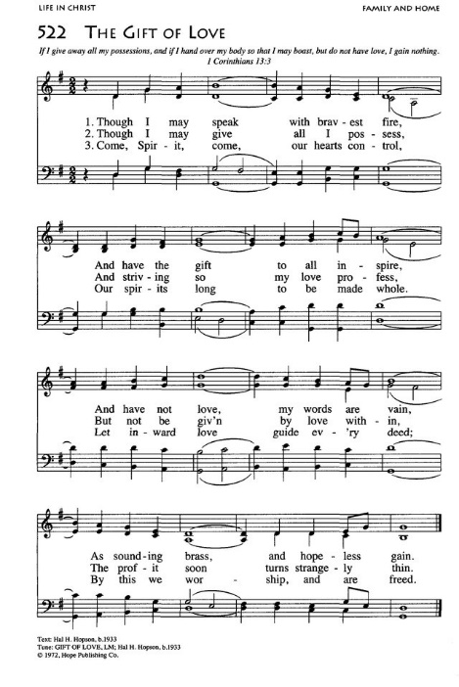

**I really like what we have been doing in this space, June. When I get up to read the scripture keep playing softly underneath. I’ll tell you when to stop.**

MESSAGE: *Both/And*

Genesis 27:5-10

5Now Rebekah was listening when Isaac spoke to his son Esau. So when Esau went to the field to hunt for game and bring it, 6Rebekah said to her son Jacob, "I heard your father say to your brother Esau, 7'Bring me game, and prepare for me savory food to eat, that I may bless you before the LORD before I die.' 8Now therefore, my son, obey my word as I command you. 9Go to the flock, and get me two choice kids, so that I may prepare from them savory food for your father, such as he likes; 10and you shall take it to your father to eat, so that he may bless you before he dies."

1 Kings 21:4-7

4Ahab went home resentful and sullen because of what Naboth the Jezreelite had said to him; for he had said, "I will not give you my ancestral inheritance." He lay down on his bed, turned away his face, and would not eat.  
5His wife Jezebel came to him and said, "Why are you so depressed that you will not eat?" 6He said to her, "Because I spoke to Naboth the Jezreelite and said to him, 'Give me your vineyard for money; or else, if you prefer, I will give you another vineyard for it'; but he answered, 'I will not give you my vineyard.'" 7His wife Jezebel said to him, "Do you now govern Israel? Get up, eat some food, and be cheerful; I will give you the vineyard of Naboth the Jezreelite."



**(MATT: please have text on screen as I read and photo on screen during sermon)**

RESPONDING TO GOD'S WORD:

Prayers of the People

BENEDICTION

POSTLUDE

The Three-Minute Suggestion:

Please spend the first three minutes with someone who is relatively new to our church family, or new to you. Get to know them like a friend might! THEN take some time with longtime friends. Thanks!

WORSHIP CONTINUES IN FELLOWSHIP:

*Coffee and Connections*

Monthly Budget: *$10,000.00*

Weekly Giving:

*11/19- $1,830.00*

Remaining: *$4,264.00*

*MONDAY: 11/27*

*AA Group -- 6:30pm*

*TUESDAY: 11/28*

*Journey singers and musicians’ rehearsal – 5:45pm*

*Handbell Practice- 7pm*

*AA Living Sober – 7:30pm*

*Woodwinds Rehearsal- 8pm*

*WEDNESDAY: 11/29*

*AA - 8pm*

*THURSDAY: 11/30*

*AA Meeting – 7:30pm*

*FRIDAY: 12/01*

*AA Meeting (Men’s) – 7:30pm*

*Saturday: 12/02*

*Wentz’s 73rd Annual Christmas Bazaar*

*LOOKING AHEAD:*

*Communion Visitation Resumes: If you or someone you know would like to receive communion at home or would like a visit from Rev or Elders in the home, please contact the office.* [*office@wentzsucc.org*](mailto:office@wentzsucc.org)

*December:*

*12/2 - 9am- 1pm Wentz’s Christmas Bazaar (Check Out Cross Words for details on how you can participate. Or contact Donna Mower – wdmower@comcast.net)*

*Ongoing:*

*If you would like to schedule time with Rev either in-person or zoom, please contact Mike via email to be placed on his calendar.* [*office@wentzsucc.org*](mailto:office@wentzsucc.org) *Evenings appointments are available.*

*Bring a friend with you next Sunday!*

*Take them out to lunch! Have a better day!*

Wentz’s UCC

Open & Affirming Statement:

We are Wentz’s United Church of Christ, an open and affirming congregation, where your identity and being are cherished. We respectfully welcome all without exception, including those of all races, ethnicities, ages, sexual orientations, gender identities, and family structures. Together we create an open and active community. Everyone is invited to walk with us in our journey. You are welcome here. Whomever, wherever, at all times.

You. Are. Simply. Welcomed.



**

Wentz’s United Church of Christ

3246 Skippack Pike Lansdale, Pa 19446

www.wentzsucc.org - [office@wentzsucc.org](mailto:office@wentzsucc.org)

610-584-4855

Rev. Dr. James L. Mills, Sr. – Senior Pastor

rev@wentzsucc.org

Ruth Geisel – Consistory President/Elder

Mike Todd- Deacon/Pastoral Assistant

Corey Taragna- Lead Trustee

Donna Mower – Guild President

June Wright- Organist

Laura McLennan and Jim O’Donnell- Music Dept

Matt MacDonald- Technology